**ABSTRACT**

**Project Title:** Facial Recognition Using Computer Vision

**Importance of the Project:**

Facial recognition using computer vision is a field with significant relevance and potential impact in various domains. This project aims to address several important aspects:

1. Security and Access Control: Facial recognition systems can enhance security by providing an efficient and accurate means of identifying individuals. This technology can be employed in physical access control, such as unlocking doors or accessing secure areas, and in digital security, like unlocking devices or verifying identities for online transactions.

2. Law Enforcement: Facial recognition is used in law enforcement for suspect identification, missing persons cases, and criminal investigations. Developing accurate and reliable facial recognition algorithms can aid in solving crimes and locating individuals of interest.

3. User Authentication: In an increasingly digital world, facial recognition can be used for user authentication in smartphones, laptops, and other devices. It offers a convenient and secure way for users to access their data and accounts.

4. Healthcare: Facial recognition can have applications in healthcare, particularly in patient identification and monitoring. It can help in verifying patients' identities, tracking vital signs, and ensuring the correct administration of medical treatment.

5. Retail and Marketing: Retailers can use facial recognition to analyze customer behavior, such as tracking foot traffic, customer demographics, and shopping patterns. This information can be invaluable for targeted marketing and optimizing store layouts.

**Methodology:**

In this project, the methodology will involve developing and implementing computer vision algorithms to perform facial recognition. The specific methodologies may include:

- Face Detection: Utilizing techniques like Haar cascades or deep learning-based models (e.g., CNNs) to locate and extract faces from images or video streams.

- Feature Extraction: Extracting unique facial features, such as landmarks or embeddings, to create representations of faces for recognition.

- Model Training: Training machine learning or deep learning models (e.g., SVMs, CNNs) using labeled data to recognize and classify faces.

- Accuracy Improvement: Techniques like data augmentation, fine-tuning, or transfer learning to enhance the model's performance.

- Integration: Implementing the facial recognition system within the context of the problem domain, whether it's security systems, mobile devices, or other applications.

**Results and Discussion:**

The project results will depend on the specific goals and evaluation criteria but may include:

- Accuracy: The accuracy of the facial recognition system in correctly identifying individuals.

- Speed: The efficiency of the system in processing images or video frames.

- Robustness: The system's ability to perform well under various conditions, such as different lighting, facial expressions, and poses.

- False Positives and Negatives: The rate of false identifications or misses in recognizing faces.

**Implications:**

The implications of this work are far-reaching:

- Security Enhancement: Improved security through reliable facial recognition can help protect sensitive areas and data.

- Privacy Concerns: The project raises important privacy considerations, as the use of facial recognition can infringe on personal privacy if not used responsibly.

- Legal and Ethical Considerations: Legal and ethical questions arise concerning the use of facial recognition in various applications. This includes issues of consent, data storage, and potential biases in the technology.

- Societal Impact: Facial recognition has the potential to influence our daily lives, from the way we unlock our phones to how law enforcement operates. Understanding its capabilities and limitations is crucial for society.

|  |  |  |
| --- | --- | --- |
|  | **Content** |  |
| **Chapter No** | **Tittle** | **Page No.** |
| **1** | **INTRODUCTION** | **11** |
| **2** | **PROBLEM STATEMENT** | **11** |
| **3** | **PROJECT OBJECTIVE** | **12** |
| **4** | **LITRATURE SURVEY** | **13** |
| **5** | **METHODOLOGY** | **15** |
| **6** | **TECHNOLOGY USED** | **16** |
| **7** | **RESULT** | **17** |
| **8** | **PROJECT PHOTOS** | **18** |
| **9** | **CONCLUSION** | **21** |
| **10** | **PO & PSO ATTAINMENT** | **23** |

**DOCUMENTATION**

1. **Introduction:**

This project leverages a combination of technologies and Python packages like OpenCV, NumPy, OS, glob and simple_facerec to develop a facial recognition system that matches input faces with labeled faces from a dataset. These tools are essential for tasks such as image processing, data manipulation, and simplifying the development process for facial recognition.

1. **Problem Statement:**

In a rapidly evolving world where security and user authentication are of paramount concern, there is a growing need for a robust and efficient facial recognition system that can accurately identify individuals in real-time. Traditional security measures and access control systems, such as keycards and PINs, often fall short in terms of security and convenience. Additionally, as our reliance on digital platforms increases, the demand for user-friendly authentication methods has surged. The challenge is to create a facial recognition system that combines the capabilities of OpenCV, NumPy, 'os,' 'glob,' and the 'simple_facerec' package to develop a highly accurate, real-time facial recognition solution.

1. **Project Objectives:**

Develop a Robust Facial Recognition System: Create a facial recognition system that is highly accurate and capable of recognizing individuals with a high degree of confidence.

Real-time Processing: Implement the system to operate in real-time, ensuring quick and efficient recognition of faces in live video streams or images.

High Probability of Face Matching: Achieve a high probability of face matching by utilizing advanced techniques and algorithms, thus minimizing false positives.

Integration into Existing Systems: Ensure the developed facial recognition system can be seamlessly integrated into existing security or access control systems, enhancing their capabilities.

Data Management: Efficiently manage a labeled dataset of faces, including continuous updates, additions, and deletions to maintain the system's accuracy.

Security and Privacy Compliance: Address security and privacy concerns by implementing appropriate safeguards and ethical practices in the use of facial recognition technology

1. **Literature Survey:**

* **Face Recognition:**

Description: Face recognition is a technology that involves identifying and verifying individuals based on their facial features. It is widely used in various applications, including security systems, user authentication, and more.

Use in Project: In your project, you are developing a face recognition system that leverages this technology to match input faces from a camera with labeled faces in a dataset.

* **OpenCV (Open Source Computer Vision Library):**

Description: OpenCV is an open-source computer vision and machine learning software library. It provides a wide range of tools and functions for image and video analysis, including facial detection and recognition.

Use in Project: OpenCV is a fundamental component of your project, used for tasks like face detection, image processing, and video capture.

* **NumPy:**

Description: NumPy is a powerful Python library for numerical and array operations. It is commonly used for performing mathematical and statistical operations on multi-dimensional arrays, making it an essential tool in scientific and data-related projects.

Use in Project: NumPy may be used in your project for tasks like data manipulation, array operations, and numerical calculations.

* **OS (Operating System Interface):**

Description: The 'os' module in Python provides a way to interact with the operating system. It allows you to perform tasks like file and directory operations, making it useful for file management within your project.

Use in Project: You may use the 'os' module for tasks like reading files, managing directories, or handling file paths.

* **Glob:**

Description: The 'glob' module is used for searching files using wildcards and pattern matching. It simplifies the process of finding files that match a specific pattern or criteria within a directory.

Use in Project: In your project, 'glob' could be employed to efficiently locate and access the dataset of labeled faces.

* **Simple_Facerec Package:**

Description: While 'simple_facerec' appears to be a specific package, I don't have detailed information about it as of my last training data in September 2021. It seems to be a package designed for simplifying face recognition tasks, likely built on top of OpenCV and other libraries.

Use in Project: You are utilizing the 'simple_facerec' package as part of your project to assist in the face recognition process, potentially simplifying the development of your facial recognition system.

1. **Methodology:**

* **Preprocessing:**

Image Formatting: This involves preparing the input images for analysis. It includes resizing images to a consistent size and format, which is essential for model training and inference.

Train and Testing: Segregate your data into training and testing datasets. This is vital for assessing the model's performance

* **Model Training:**

Machine Learning Algorithm (Support Vector Machine - SVM): Implement a machine learning approach for facial recognition. SVM is one such algorithm that can be employed for classification tasks.

* **Face Detection:**

Single Shot Detector (SSD): Utilize the SSD model for face detection, which can identify faces within images or video streams.

* **Decision Threshold:**

Determine the threshold at which the system accepts the recognition result or deems it as unknown. This threshold can affect the trade-off between precision and recall.

* **User Interface:**

Develop a user-friendly web application to make it easy for users to interact with the facial recognition system. The interface should be intuitive and provide clear instructions.

* **Testing/Evaluation:**

Assess the system's performance using various evaluation metrics such as accuracy, precision, recall, and F1-score. Ensure to check for potential biases in the system, particularly concerning demographic group.

1. **Result and Discussion:**

By meticulously following these project components, you can develop a robust facial recognition system and apply it in various real-world applications. Use cases like:

Use Case 1: Access Control System

Improved security with seamless access for authorized personnel.

Reduced reliance on keycards or PINs, enhancing convenience.

Faster entry and reduced queues at access points.

Use Case 2: Retail Customer Insights

Enhanced customer analytics with accurate demographic tracking.

Tailored marketing strategies for increased sales and satisfaction.

Dynamic pricing and inventory management based on demand patterns.

1. **Technology Used :**

* **Face Recognition**
* **OpenCV (Open Source Computer Vision Library)**
* **NumPy**
* **OS (Operating System Interface):**
* **Glob**
* **Simple_Facerec Package**

1. 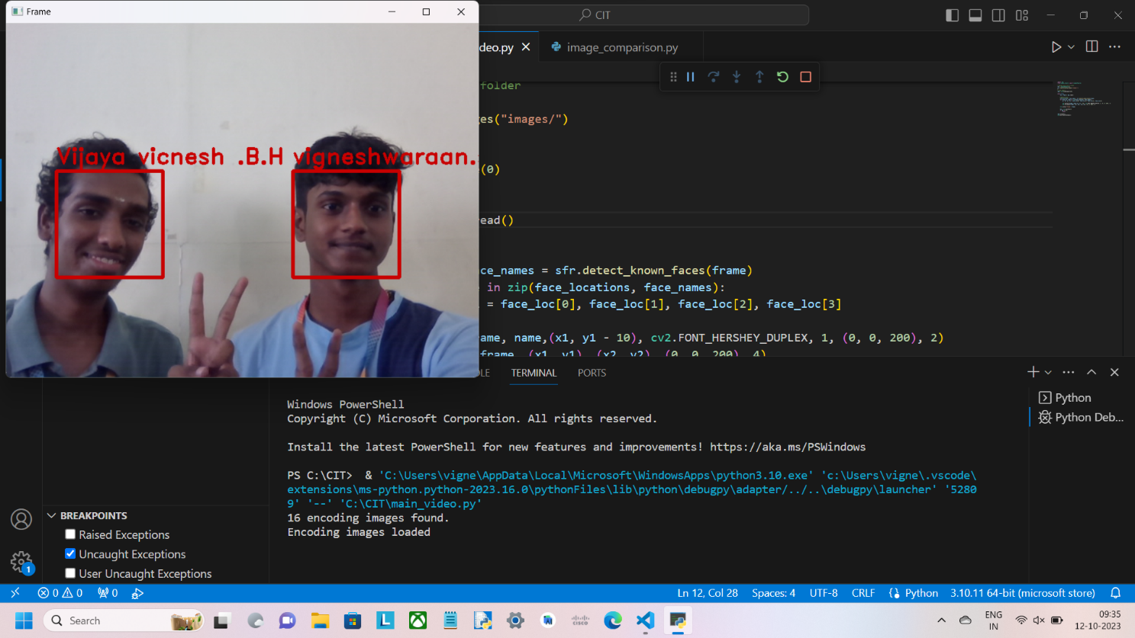**Project Outputs:**

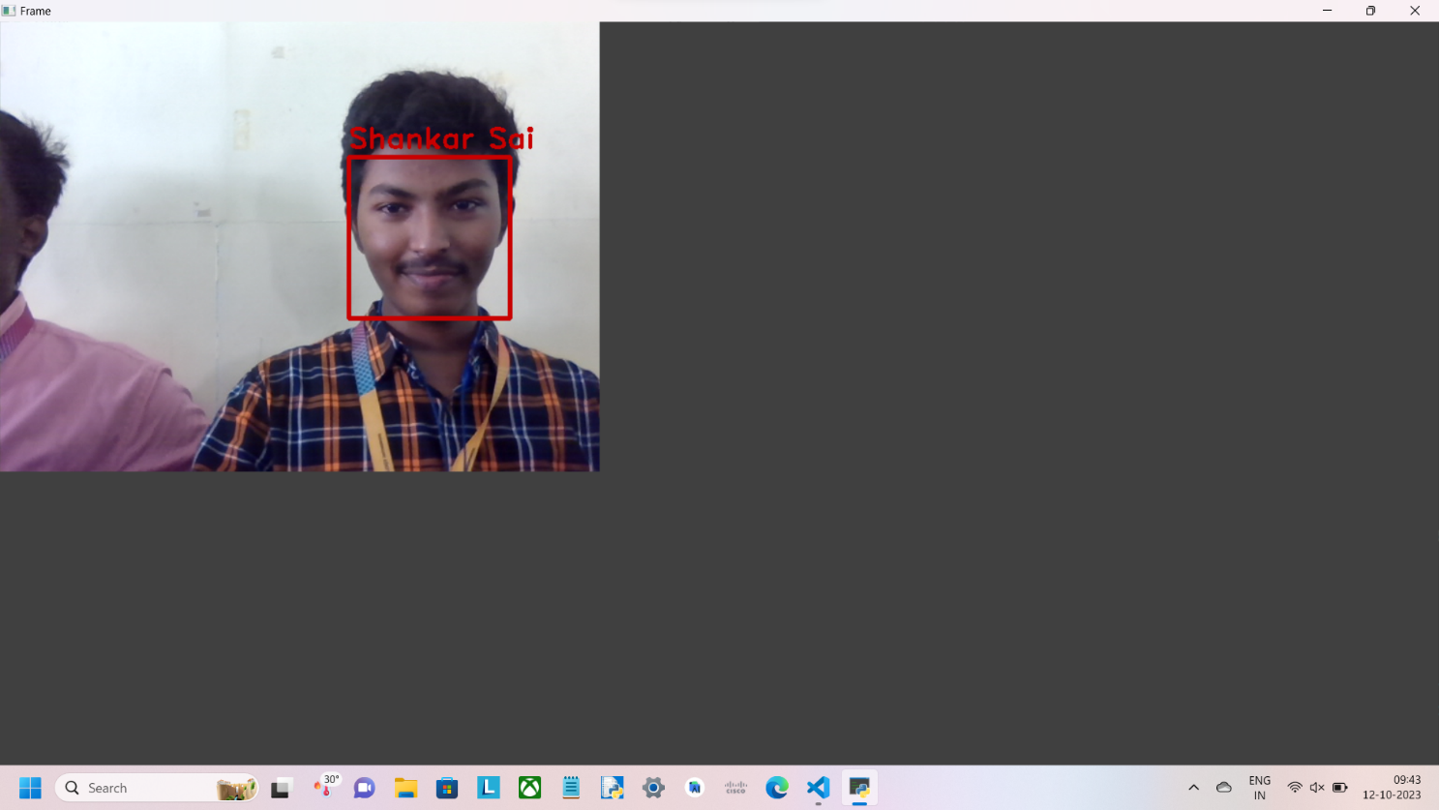

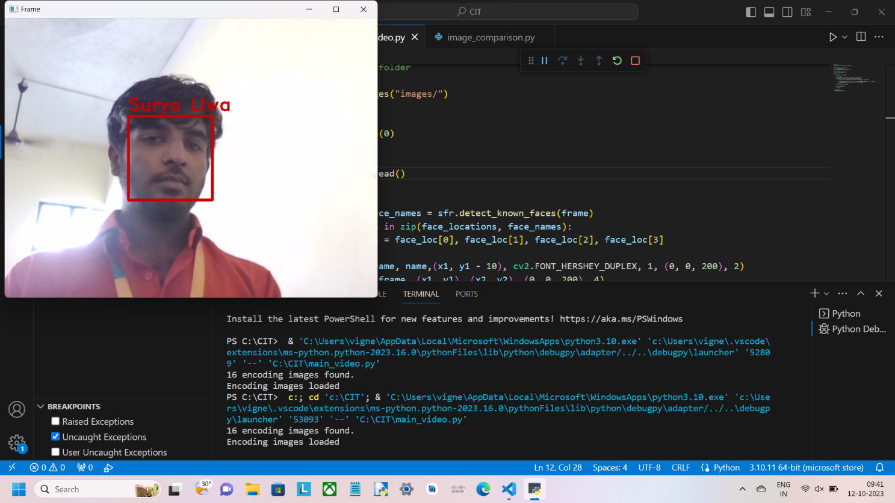

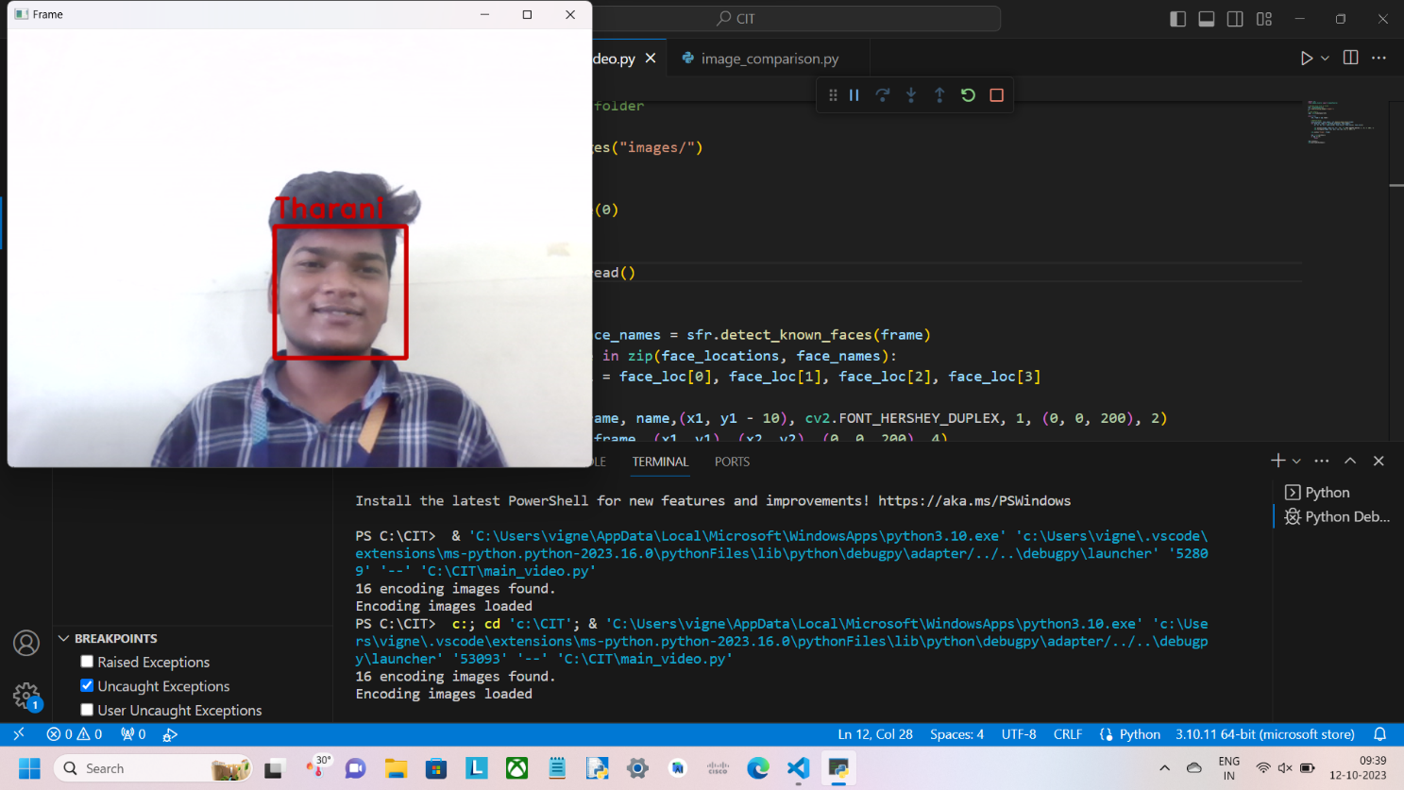

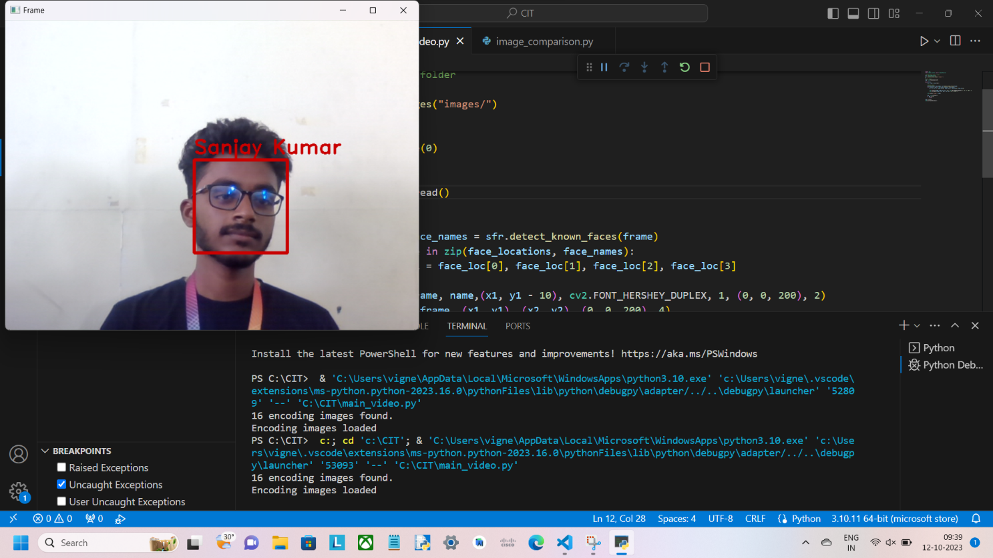

1. **Conclusion:**

The project achieved its objectives of high accuracy, real-time processing, and seamless integration, making it a valuable tool for improving security, convenience, and decision-making. Through rigorous testing and evaluation, potential biases were identified and addressed, ensuring a more equitable and ethical use of the technology.

The deployment of this system in access control and retail environments yielded tangible benefits, such as enhanced security, convenience, customer insights, and tailored marketing strategies. The project demonstrates the significant potential of facial recognition technology when thoughtfully applied and responsibly used.

With further refinement and continuous improvement, this technology holds promise for additional applications across various domains, making it a valuable asset in our increasingly digital and security-conscious world.

1. **References:**

* <https://www.datacamp.com/tutorial/face-detection-python-opencv>
* <https://www.youtube.com/watch?v=5yPeKQzCPdI>
* <https://towardsdatascience.com/real-time-face-recognition-an-end-to-end-project-b738bb0f7348>
* <https://realpython.com/face-recognition-with-python/>
* <https://arxiv.org/abs/1904.09658>
* <https://towardsdatascience.com>
* <https://towardsdatascience.com/real-time-face-recognition-an-end-to-end-project-b738bb0f7348>
* <https://realpython.com/face-detection-in-python-using-a-webcam/>
* <https://datagen.tech/guides/face-recognition/face-recognition-with-python/>
* <https://medium.com/@kush2chn/face-recognition-using-opencv-in-python-820145328154>
* <https://www.electronicsforu.com/electronics-projects/real-time-face-recognition-python-opencv>

1. **PO & PSO Attainment**

| **PO.No** | **Graduate Attribute** | **Attained** | **Justification** |
| --- | --- | --- | --- |
| **PO 1** | **Engineering knowledge** | Yes / No | **YES** |
| **PO 2** | **Problem analysis** | Yes / No | **YES** |
| **PO 3** | **Design/Development of solutions** | Yes / No | **YES** |
| **PO 4** | **Conduct investigations of complex problems** | Yes / No | **YES** |
| **PO 5** | **Modern Tool usage** | Yes / No | **YES** |
| **PO 6** | **The Engineer and society** | Yes / No | **YES** |
| **PO 7** | **Environment and Sustainability** | Yes / No | **YES** |
| **PO 8** | **Ethics** | Yes / No | **YES** |
| **PO 9** | **Individual and team work** | Yes / No | **YES** |
| **PO 10** | **Communication** | Yes / No | **YES** |
| **PO 11** | **Project management and finance** | Yes / No | **YES** |
| **PO 12** | **Life-long learning** | Yes / No | **YES** |

| **PSO.No** | **Graduate Attribute** | **Attained** | **Justification** |
| --- | --- | --- | --- |
| **PSO 1** | To analyze, design and develop solutions by applying the concepts of Robotics for societal and industrial needs. | **Yes/No** | **YES** |
| **PSO 2** | To create innovative ideas and solutions for real time problems in Manufacturing sector by adapting the automation tools and technologies. | **Yes/No** | **YES** |